**Project Design Phase**

**Problem – Solution Fit**

|  |  |
| --- | --- |
| Date | 09 February 2026 |
| Team ID | LTVIP2026TMIDS66315 |
| Project Name | Explore With Ai: Custom Itineraries For Your Next Journey |
| Maximum Marks | 2 Marks |

**Problem – Solution Fit:**

The **Problem–Solution Fit** for *Explore with AI* focuses on addressing the common challenges faced by travelers in planning personalized trips efficiently and without stress.

**Purpose:**

❑ To solve the problem of time-consuming and manual travel planning by providing an AI-powered automated solution.

❑ To improve solution adoption by aligning with modern user behavior, where users prefer quick, web-based, and personalized digital tools.

❑ To clearly communicate the value of AI-driven itinerary generation as a faster and more efficient alternative to traditional travel planning methods.

❑ To reduce frequent user frustrations such as scattered travel information, lack of personalization, and repetitive research efforts.

❑ To understand traveler needs and improve the planning experience by delivering structured, day-wise, and customized travel itineraries.

**Template:**

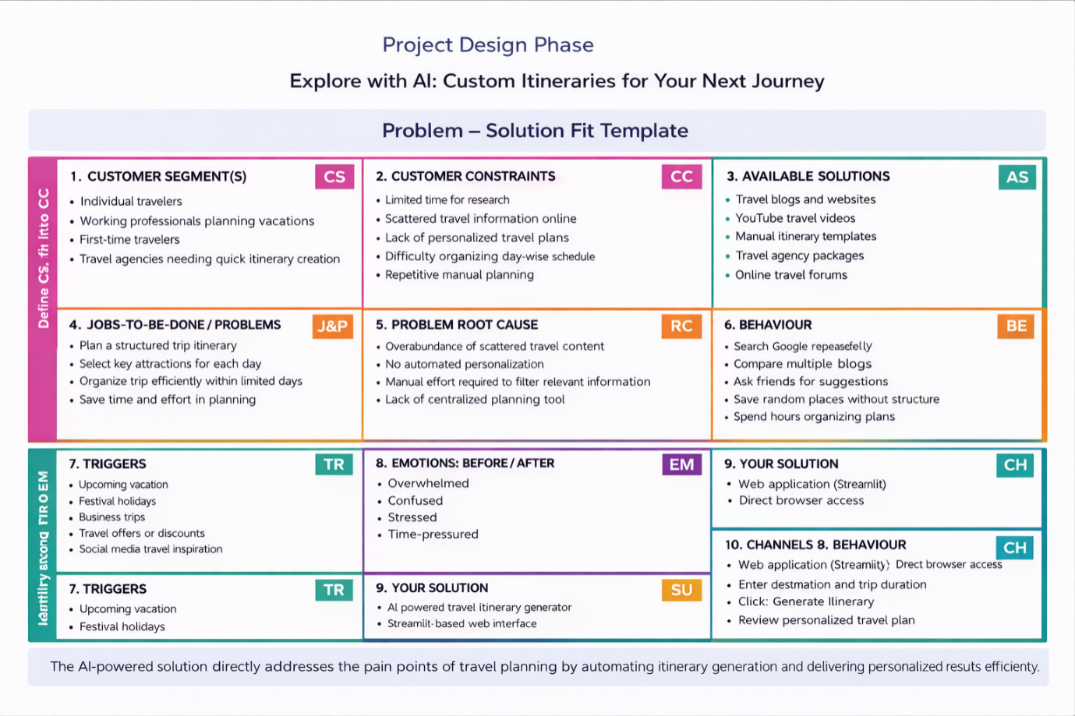

References:

1. <https://www.ideahackers.network/problem-solution-fit-canvas/>
2. <https://medium.com/@epicantus/problem-solution-fit-canvas-aa3dd59cb4fe>